

Business Functional Specifications

R&BS Fee Schedule Work Flow for Corporate Trust

(FLW) Technology

Date: 12-06-17

Version 1.7

Document Information

**Document History**

|  |  |  |  |
| --- | --- | --- | --- |
| Version | Author(s) | Comments/Changes | Revision Date |
| .01 | Richard Storey | Initial version of FRD | 5/4/17 |
| .02 | Richard Storey | Technical Review Copy | 5/18/17 |
| .03 | Richard Storey | Updated Role Support (Section 4) | 5/30/17 |
| .04 | Richard Storey | Updates to PDF formatting /display (Sec 7) | 6/1/17 |
| .05 | Richard Storey | UI changes for Role Support (Section 4), Add Service Descriptor Note type (Sec 6), PDF formatting (Sec 7) | 6/21/17 |
| .06 | Richard Storey | Specification to R&BS Technology for review prior to full release | 6/30/17 |
| .07 | Richard Storey | Continued Review with Technology | 7/7/17 |
| .08 | Richard Storey | FeeFlow Technology Release | 7/11/17 |
| .09 | Richard Storey | Product Catalog Group Release | 7/13/17 |
| 1.0 | Richard Storey | Release Version | 7/21/17 |
| 1.1 | Richard Storey | Engage ID support (Section 4) | 8/3/17 |
| 1.2 | Richard Storey | Free Text support for Service Descriptors (6) | 8/10/17 |
| 1.3 | Richard Storey | Nexen Format Deal Summary, L2 and L3 Screen shots. Service Descriptor Details, Removed Engage ID search from Landing Page | 11/6/17 |
| 1.4 | Richard Storey | Removed Engage ID from Deal Summary Screen; removed Engage ID field references | 11/14/17 |
| 1.5 | Richard Storey | Added Terms and Conditions detail to Section 6 | 11/27/17 |
| 1.6 | Richard Storey | Changed “Company” to “you” in PDF intro paragraph | 12/5/17 |
| 1.7 | Richard Storey | Changes to FeeFlow’s Appendix A and B (sec 6); Field length for Maintain Cover Page (sec 7) | 12/6/17 |

Table of Contents

1. Project Overview 6

1.1 Purpose 6

1.2 Background 6

1.3 Requirements Summary: Phase 3 6

2. Scope 8

2.1 Scope Summary for Release 1A: November 2017 8

2.2 Scope Summary for Release 1B: March 2018 8

2.3 1A Exclusions: 8

2.4 The 1A Deliverable: 8

2.5 Document Scope 8

2.6 Scope Diagram Release 1A 9

2.7 Scope Assumptions 9

2.8 Future State 9

3. Corporate Trust Fee Schedule Support 10

3.1 Corporate Trust Required Changes for Release 1A 10

4. Corporate Trust Fee Schedule Details 11

4.1 Corporate Trust Fee Elements 11

4.2 CT Role Support: 11

4.3 Role-based and Schedule-based Fee Types 14

4.4 Legal Entity Support 14

5. Fee Flow Fee Schedule Product Catalog: 17

5.1 Corporate Trust Product Catalog Sample 17

5.2 FeeFlow Product Catalog w/ Corporate Trust Mapping. 17

5.3 Product Display: Standard/Mandatory/Optional 21

6. Note Support 22

6.1 Footnotes and Additional Notes 22

6.2 Terms and Conditions 23

6.3 Service Descriptor: 24

7. Corporate Trust Fee Schedule PDF Output 28

7.1 Fee Schedule Samples (Distribution and Annotated) 28

7.2 Fee Schedule CT PDF Format Enhancements 28

8. FeeFlow System Screens 33

8.1 FeeFlow Landing Page (Sign-in page) 33

8.2 Figure 2 Deal Summary Screen (Create Fee Schedule) 36

8.1 Fee Schedule – Product Selection 38

9. Fee Schedule Approval 42

10. Tier Pricing Details for CT 43

10.1 Tier Types 43

10.2 Tier Fee Rules 43

10.3 Step Tier Fee: Input Scaling 45

11. Corporate Trust Key Requirements 46

11.1 Workflow and Approval Process 46

11.2 Entitlement Support – On Hold for Release 1A 48

12. Glossary of Terms 52

12.1 Terms and Abbreviations 52

13. Appendices 53

13.1 Corporate Trust Product List 53

13.2 Product Catalogs List (Sharepoint Link) 54

13.3 Charging Basis List 54

13.4 Pricing Method List 55

13.5 Fee Period List 55

13.6 Corporate Trust Region & Currency Lists 56

13.7 Client Type List 57

13.8 Terms and Conditions Catalog Sample 57

**List of Stakeholders**

|  |  |  |  |
| --- | --- | --- | --- |
| **Stakeholder** | **Subject Matter Area** | **Required for Sign-off** | **Sign-Off** |
| Tom Dietsch | R&BS Manager | No |  |
| May-Ling Yip | Corporate Trust Pricing | No |  |
| Joseph Zorn | Corporate Trust Pricing | Yes | 7/24/17 |
| Alan Geraghty | Corporate Trust | No |  |
| Susan McGee | R&BS | Yes | 8/21/17 |
| Kristi Dirosa | R&BS | Yes | 8/22/17 |
| Mike Sibley | BPS Program Management | No |  |
| Christine Denmore | Risk | No |  |
| Fei-Wen Wong (Vivian) | R&BS Technology | Yes | 8/22/17 |
| Joe Coudriet | CT Business Process Automation | No |  |
| Brian Sabel | CT Client Automation – DOS | No |  |
| Jonathan Sharpe | Asset Servicing | No |  |
| Michelle Blair | R&BS Prod Dev & Revenue - FiRRe | No |  |
| Viswa Mareddy | R&BS Technology | Yes | 7/12/17 |
| Alex Rafailov | R&BS Technology | Yes | 7/13/17 |
| Chanchal Bera | Technology | No |  |
| Hitesh Jain | Technology | No |  |

# Project Overview

## Purpose

* The need to create a structured Fee Schedule creation process that integrates FeeFlow into Corporate Trust’s Phase 3 Project
* Provide an automated Fee Schedule solution to integrate with Engage/DOS/FiRRe to provide an integrated Fee Schedule creation and management system.

## Background

* Corporate Trust has built a foundation of data and deal management services, leveraging its Deal Onboarding Solution, CT partners with Revenue Billing Services to automate the billing process in 3 strategic phases.
  + Phase 1 – Re-engineering CT to the Revenue Billing Services
  + Phase 2 – Automation of the Billing Account Opening
  + Phase 3 – End to End (E2E) Billing/Fee Schedule Automation
* The Business Requirements assume completion of Phase 2 and focus on Phase 3 – E2E Billing/Fee Schedule Automation
* The FeeFlow system will be part of Phase 3
* Note: for Phase 3 the FeeFlow implementation consist of 2 releases.
  + Release 1A
    1. Release 1A will provide Fee Schedule generation capability for a defined segment (US Pensions, EMEA) of Corporate Trust’s Regions and Products (See Appendix **13.1.1**.) This release will not include any interfaces with 3rd party systems
    2. Note: Additional groups of Coporate Trust products will be scheduled and added after the initial 1A release (See Appendix **13.1.2** for the full list)
  + Release 1B
    1. Loading approved Fee Schedule detail into the Corporate Trust Billing Systems
    2. System to System interfaces with DOS and FiRRe13.1.1

## Requirements Summary: Phase 3

This section references the “CT RBS End to End Billing Fee Schedule Automation -Phase 3 Business Requirements Document”

<https://myshare.bnymellon.net/sites/fmtsebu/corporatetrustfeescheduleworkflow/Shared%20Documents/Corporate%20Trust%20Project/3.%20Definition/Business%20Requirement%20Document/Corporate%20Trust%20FeeFlow%20BRD.docx>

The objective is a solution that meets the requirements of Phase 3 which include at a high level:

**Fee Schedule Creation– Release 1A**

* Creation of Fee Schedules based on existing Corporate Trust Catalogs and Fee Structures
* The need to provide an automated process for Fee Schedule creation and approval
* Standardizing the Product Offerings & Services based on Corporate Trust regions
* Pre-populating all region specific services for those selected Products
* Pre-selection of services for the Fee schedule from standardized Product Catalogs
* Flexible selection of supporting text: Appendices, Footnotes , Additional Notes and Service Descriptors
  + Available at the 1) fee schedule level, 2) Service Group level, 3) individual service level
  + Footnotes, Additional Notes and Service Descriptors text will be setup in the system prior to usage. Users will not be able to modify the text for Footnotes , Additional Notes and Service Descriptors during fee schedule setup
  + FeeFlow will allow users to add ad-hoc text in the Appendix section during schedule setup
* Provide ability to review draft and final fee schedules in client distribution format (PDF)
* Provide flexible and multi-stage approval and review process in the User Interface (UI)
* Provide entitlement support to assign user roles and responsibilities for fee entry and approval
* Provide ability to clone fee schedules to produce multiple schedules off of a single template
* Ability to record the approval of client’s signed fee schedule.
* Provide ability to retrieve & copy a stored fee schedule so that it can be used to draft a new or reprised fee schedule.
* FeeFlow solution should provide archive and retrieval capabilities for client distributed fee schedules in PDF format.

**System Interfaces: Release 1B (Note Details will provided in a separate FRD)**

* Fee Component upload to the FiRRe billing system
* Data transformation of Fee Schedule details to map to FiRRe billing system.
* Fee Components and mapping rules for all standard/non-standard fee templates
* Provide status and audit reporting to track upload status within FeeFlow system
* Provide data locking and release functionality to insure data integrity of uploaded files
* Ongoing synchronization with FiRRe fee structures
* Will be integrated into the DOS/FiRRe work flow
* Provide file fail processing and reporting that identifies specific areas of success and/or failure

**Information interface with 3rd Party Systems – Release 1A**

* 3rd party System will be able to make an API call to FeeFlow to get Fee schedule inform
* Implementations of FeeFlow release 1A should not impact current CT Phase 2 project of integrating DOS with FiRRe

# Scope

## Scope Summary for Release 1A: November 2017

* US Public Finance and EMEA Corp Sovereign products will be for the initial deliverable
* See Appendix 1 (Section **13.1.1**) for list of products to be delivered for Release 1A.
* Remaining Corporate Trust Products for subsequent releases are also listed.
* Current FeeFlow front end User Interface is expected to be used with minimal modifications
* Ability to create the fee schedules that conform to Corporate Trust Requirements,
* A formal Fee schedule approval process with approval tracking ,
* Output of Interim and final fee schedules to PDF format for review and approval
* Version control and retrieval of created fee schedules

## Scope Summary for Release 1B: March 2018

* Loading approved Fee Schedule detail into FiRRe billing System – Not covered in this document.
* Basic integration with existing Deal Onboarding Solution Process– Not Covered in this document

## 1A Exclusions:

* Nexen Support
* Automated integration of FeeFlow with DOS via Nexen (For Release 1B or later)
  + Note: some manual integration with DOS will be required to avoid data and process flow problems.
* Automated Integration with Engage account setup:
* Pass fee schedule details in a data format directly from FeeFlow to Corporate Trust’s billing systems (DOS and FiRRe) – Release 1B Not Covered in this document

## The 1A Deliverable:

Release 1A will provide Functional Fee Schedule generation capability for defined segments (US Pensions, EMEA) of Corporate Trust’s Regions and Products. Using FeeFlow CT users will be able to:

* Generate Fee schedules for an agreed set of Products and Roles
* Review and approve the fee schedules using CT process detailed in this document.
* Generate fee schedules in PDF format that will be valid for Deal Onboarding.

## Document Scope

This Functional specification will cover the following areas

* Corporate Trust’s Product, Role and Service hierarchy structure and how they will be supported in FeeFlow
* Corporate Trust’s Fee Schedule and Pricing requirements and how they will be addressed in Fee Flow
* Identification of specific technical requirements to convert the current Asset Service version of FeeFlow to support Corporate Trust Requirements
* The list of Corporate Trust Products that will make up the initial deliverable
* Specific technical changes to FeeFlow required to address the Corporate Trust implementation
* Required changes to Fee Schedule formats to meet Corporate Trust User requirements
* Business and Operational procedures to produce Fee Schedules

**Note:** The details of the interface between FeeFlow and FiRRe (Release 1B) will be out of scope for this document and will be detailed in a separate specification

* Specific items related to the interface to the FiRRe system
* Interface file specifications
* File transmission: System interfaces
* Fee Schedule Mapping between FeeFlow and FiRRe
* Interface related reconciliation between FeeFlow and FiRRe

## Scope Diagram Release 1A

**Note:** Dotted Lines indicate user manual entry or circulation of PDF format documents. For this release there will be no system to system interfaces and the process will be manual



## Scope Assumptions

* Fee Schedule setup in FeeFlow will be manual and be part of the initial deal development process involving the Corporate Trust Relationship teams.
* FeeFlow Fee Schedule ID and Fee Schedule details will be passed to the DOS system manually either as part of the Manual Fee schedule setup process or at a later stage of deal confirmation.
* Any Fee Component details from FeeFlow will be added manually to DOS by DOS
* FeeFlow will be the system of record for Fee Schedule details, DOS will be the system of record for all account and legal entity related details.

## Future State

* Full end to end integration with Engage and Deal Manager
* Expansion of Fee Flow for CT to all remaining CT products
* Expansion to all CT regions
* Utilization of Nexen capabilities

# Corporate Trust Fee Schedule Support

## Corporate Trust Required Changes for Release 1A

### Add “Corporate Trust” entry to Line of Business Drop Down in Deal Summary Screen (See Section 8.2)

* Selection of “Corporate Trust” initiates Corporate Trust specific Fee Schedule templates, UI changes and CT specific data.
* Drop-down lists on the Deal Summary screen like region and client type will only contain those items designated by Corporate Trust. There will be no comingling with Asset Servicing descriptions.

### Add Corporate Trust Role Functionality

#### Incorporate Corporate Trust role descriptions into the Product Catalogs, UI selection and PDF output (See Section 4)

### Changes to Fee Schedule PDF generation that incorporates Corporate Trust formatting and terminology (See Section 7)

### Add Service Descriptor: Additional text that is grouped under the service lines. (See Section 6.3)

### Add Legal Entity Drop-Down to Deal Summary Screen (See Sections 4.4, 8.2)

### Increase number of Regions to 7 (See Appendix 13.6)

### Increase number of possible Pricing Tiers from 5 to 9 (See Appendix Section 10.2)

### Add Banded Tier and Flat Tier Functionality (See Appendix Section 10.1)

# Corporate Trust Fee Schedule Details

## Corporate Trust Fee Elements

The FeeFlow solution needs to conform to and support Corporate Trust’s Fee Structures and Hierarchy. CT Fee Hierarchies are based around the following components:

| Entity | Description | Examples/Comments |
| --- | --- | --- |
| Line of Business (LOB) | Business Unit | Corporate Trust |
| Region | Business Regions | For example US, EMEA, APAC |
| Account Name | Client Name: Can be left blank during fee negotiations for non-disclosure | One of either account name or project name must be entered during fee negotiation. |
| Project Name | Project Name | Used if additional project name required. Can also be used as an account alias for non-disclosure situations. |
| Product | Product or service being sold. It is the same as the current FeeFlow Product | ABS, Custody, General Obligation Bonds |
| Role | Person that performs a specific function for the product(s) sold or a General Description for activity based fees | Trustee, Paying Agent, Cash Manager: |
| Role-based fee | Fees that are allocated to specific Roles, and are charged each time for each role | Paying Agent Fee  Receiving Escrow Agent Fee |
| Schedule-based Fee | Fees that cover the whole fee schedule and are not limited to roles in the fee schedule and are only charged once. | Acceptance Fees, Activity Fee’s  Service Fees |
| Service | Lowest level of pricing hierarchy, activity or value. where fee amounts are listed | Note Trustee Acceptance Fee |
| Client Type | Client Grouping that determines special product selection for Asset Servicing. | Use current FeeFlow functionality; Corporate Trust to provide the list. |
| Legal Entity | Governing Legal Authority for each role/fee service | The legal entity will be added in the Deal Summary screen as part of deal setup. |

## CT Role Support:

1. The major difference between Corporate Trust and the current Asset Services versions of Fee Flow is the need to support Roles. A role is a Person or a group that performs a specific function for the product(s) sold. It can also be used as a higher level identification for activity based fees. Roles are determined by the RM during the initial business discussions. They can be included in the Fee Schedule in specific listed fees. The role names will be identified on the schedule cover page entered by the user. Note: not all fee services are tied to roles. Some fees cover the entire schedule and assume all roles
2. Currently Corporate Trust Fee schedules are manually produced. Fee Schedules with the designated roles and fees are sent to DOS after (or just preceding) client approval. DOS assigns additional account details and determines the legal entities for the business (also referred to as an “assignment”)
   1. FeeFlow will need to support the full list of roles for a given product
   2. FeeFlow will need to support specific role based fees
   3. Fee Flow will need to support fees that are schedule-wide and include all roles
3. Corporate Trust Fee Schedule components will be based around the following hierarchy structure: that is setup in the Product Catalogs.
   1. LOB 🡪 Region 🡪 Product 🡪 Service Group 🡪 Multiple Services - Roles
   2. LOB and Region determine the list of Products
   3. Product will restrict the selection of Service Groups to just those designated for the Product.
   4. Selection of Service Group will identify the available fee services -Roles.
   5. The available services will have the available roles listed as part of the service description.
   6. Note there can be multiple roles for a single service name; however, Services and roles will be concatenated in the following format: [Service Name] – [Role] for the UI and PDF Schedules. FeeFlow will look at this combined “[Service Name] – [Role]” to determine if items are unique or are being repeated.
4. The hierarchy selection detailed above will be supported through the current FeeFlow product Catalog Structure with the following modifications. (See Section **5.1)**
   1. An additional Roles column will be added to the current Product catalogs Product Catalog Load routine will need to be amended to add the new fields.
5. Within FeeFlow Services and Roles from the product catalog will be joined together and presented as a single concatenated entity within FeeFlow’s current service line.
   1. For example if the catalog Role is Escrow Agent and the Service is Annual Fee, then the concatenated Service/Role would be “Annual Fee – Escrow Agent”
   2. The Service/Role is in the same data hierarchy level as Service in the current Asset Services version of FeeFlow
6. Service/Roles would be selected through the FeeFlow User Interface (L2 screen)

L2 Screen

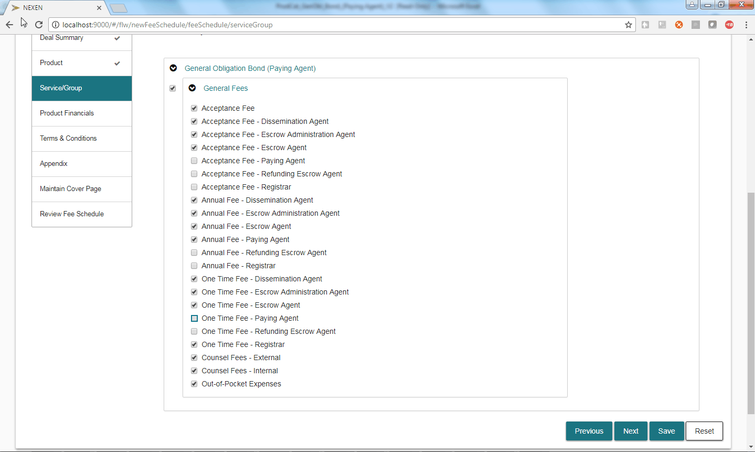

1. Selection of the Product and the Service Group will produce the full list of Service/Roles
2. Selection of the Service/Roles (🗹) will bring up the fee details on the L3 screen
3. The fee details for the Service/Roles would be managed through the L3 screen

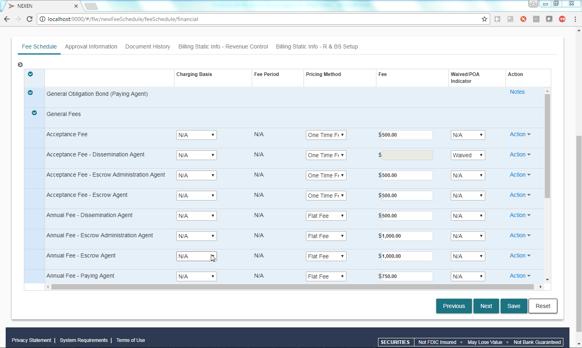

1. Role’s designated “N/A” in the product catalog will not display in the UI or the PDF fee schedule (See fee schedule sample Section **7.1)**
   1. For Role: “N/A” and Service “Acceptance Fee”: Service/Role = “Acceptance Fee”

## Role-based and Schedule-based Fee Types

1. Corporate Trust Fee Schedules contain both Role-based and Schedule-based Fees
   1. Role-Based Fees are limited to the Roles designated for the schedule. Certain Services might be charged once for each role. For Example:
      1. Annual Fee – Escrow Agent (for Role “Escrow Agent”)
      2. Annual Fee - Paying Agent (for Role “Paying Agent”)
   2. Schedule–based Fees are applicable for the entire fee schedule and are charged only once. For Example:
      1. Acceptance Fee
      2. Activity Fees
         * Wire Fees
         * Counsel Fees

## Legal Entity Support

### Corporate Trust Fee Schedules reference Legal Entity in the Following Section

**Fee Schedule**

Subject to the Terms and Disclosures - General below, upon appointment of [**BNY Legal Entity]** (**“**BNYM” or “us” or “affiliates” or “subsidiaries**”)** in the roles as outlined within this Fee Schedule (this “Fee Schedule”), Washington Unified School District (“Customer”) shall be responsible for the payment of the fees, expenses and charges as set forth in this Fee Schedule.

* 1. User needs the ability to enter a Legal Entity Value during deal setup in the Deal Summary Screen. This value will be used to populate the [**BNY Legal Entity]** data element in the Fee Schedule template
     1. Use current Asset legal entity selection functionality that is used for the signature page

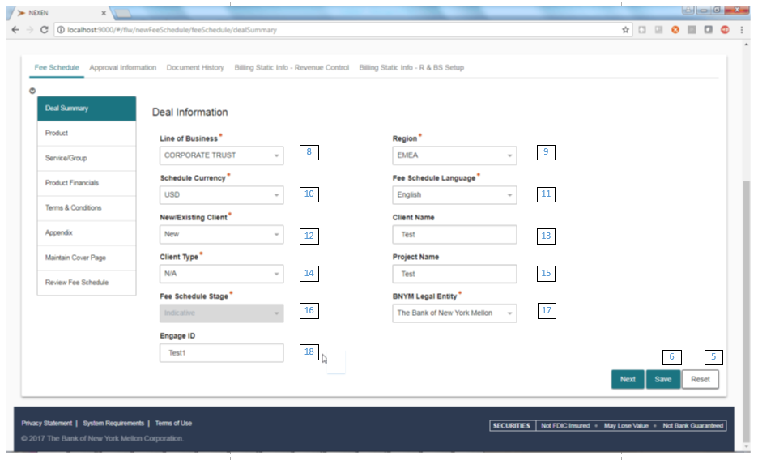

* 1. Legal Entity drop-down selection will only be available if Line of Business = “Corporate Trust”
  2. Legal Entity drop-down selection will include the full list of available Legal Entities. In addition the drop-down will include a general description “Bank of New York, Mellon”.
  3. The Corporate Trust user must select an actual legal entity or a general description.
  4. Like Client name and Project name, the BNYM legal entity field can be changed up until the final schedule approval lock-down step. The field will be optional until the final stage of approval; then it becomes mandatory
  5. Corporate Trust background information on legal entities:
     1. Fee Schedules will only list one legal entity selected from the Deal Summary Screen
     2. Note when schedule details are added to the DOS system, additional Legal Entities may be added.
     3. Legal Entities are required for FiRRe to setup client invoices

1. In the case where a single fee schedule may have multiple legal entities; FiRRe will need separate accounts for each DOS deal ID and each of the legal entities
2. FiRRe will need to have the fee services grouped by each separate FiRRe account
3. For release 1B: If there are multiple account/legal entities, the FeeFlow interface will need to split the schedule’s fee services and group them by each FiRRe account.
   * 1. For release 1A: FeeFlow will provide fee schedule details (hardcopy initially) to DOS that will detail roles and services to help with this process.
4. FeeFlow will current functionality to select the Legal Entity on the signature page
   1. See Section 7 for Fee Schedule Signature details

# Fee Flow Fee Schedule Product Catalog:

For Corporate Trust fee structures will be setup using current Product Catalog functionality. The product catalog provides a great deal of flexibility to: a) define Fee Schedule names, b) set defaults and c) set mandatory entries.

For Corporate Trust a new field “ROLE” will be added to the current product catalog. When the catalog is loaded Fee flow needs to:

* 1. Concatenate the Service and role descriptions: [SERVICE] – [Role] and display in the UI
     1. If [ROLE] = “N/A” then only the service description will be visible
  2. Store the role description separately as its own data element in the FeeFlow database.

The Catalog identifies by Product: a) the Service and Service Groups to be selected, b) the order they are displayed, c) whether a default value will be displayed and d) whether that value is optional or mandatory.

The major products identified by corporate trust will be incorporated into the following structure

## Corporate Trust Product Catalog Sample

https://myshare.bnymellon.net/sites/fmtsebu/corporatetrustfeescheduleworkflow/Shared%20Documents/Corporate%20Trust%20Project/3.%20Definition/Product%20Catalogs/Fee%20Flow%20Prod%20Catalog%20Corp%20Trust%20Finalized/ProdCat_High%20Yield%20Bond.xlsx

## FeeFlow Product Catalog w/ Corporate Trust Mapping.

**Note:** UI Change Value Field Key:

D = Drop Down/Checkbox,

O = Overwrite,

N = Can’t Change,

N/A = Not Applicable

| # | Corp. Trust Description | Fee Flow Catalog | Required | Descriptions | UI Change Value (D,O,N, N/A) | Comments /Examples |
| --- | --- | --- | --- | --- | --- | --- |
| 1 | Product (USA)  Sub-Product (EMEA) | PRODUCT | Y | The High Level Product for the Fee Schedule. | D | ABS, General Obligation Bonds  Note: Product Display needs to be suppressed in Schedule PDF (See Section **7.2.1)** |
| 2 |  | PRODUCT DISPLAY ORDER | Y | For Lines of business with multiple Products: This defines the display order. | N/A |  |
| 3 | Fee Type | Service Group | Y | A Grouping level to organize the roles and services for a given product.  For corporate trust this is similar to a fee type. | D |  |
| 4 |  | Service Group DISPLAY ORDER | Y | Defines the display order for Service Groups | N/A |  |
| 5 |  | Role | Y | A Person that performs a specific function for the product(s) sold or a higher level grouping for activity based fees | N/A | Can use “N/A” to hide display in PDF Schedule if required |
| 6 | Description | SERVICE | Y | Individual Fee line items | D |  |
| 7 |  | SERVICE DISPLAY ORDER | Y | Defines the display order for Services | N/A |  |
| 8 |  | STANDARD Y/N | Y | “Y” or “N” | N/A | IF “Y” then Service will be pre-selected in the UI. If “N” then service checkbox will be blank  See Section 5.3 |
| 9 |  | MANDATORY/OPTIONAL | Y | “M” or “O” | N/A | If “M”: checkbox cannot be deselected. (note Standard must = “Y”).  If “O” then checkbox can be selected/ deselected in UI .  (Standard can be “Y” or “N”)  See Section 5.3 |
| 10 |  | MARKET | Y | Market Code: Use specific market code or “All” to display all markets  “N/A” to hide display | D | Location of fee Activity. Use “All” to display all markets  Only available for Global Custody. If not needed use N/A to hide display |
| 11 |  | Security Type | Y | All, Bonds, Equities ,( user defined types recognized by the billing system )  Use “All” if no specific securities  “N/A” to hide display | D | Fees can be assigned to Security Types .  E.g. “Bonds”, “Equities”  Only available for Global Custody.. If not needed use N/A to hide display |
| 12 |  | Depo | Y | Depository Codes recognized by Billing System. Use “All” if no specific depositories  “N/A” to hide display | D | Fees can be assigned by Depository.  Only available for Global Custody. If not needed use N/A to hide display |
| 13 |  | CHARGING BASIS | Y | * Per Position * Per Account * Per Leg * Per Holding * Per Month * Per Item * Per Unit | D | Determines the charging basis display in the PDF fee schedule.  A certain amount of flexibility is available , but CT should try to standardize as much as possible.  (See Appendix 10.3 for full list) |
| 14 |  | PRICING METHOD | Y | Fee calculation method   * Unit * Value * Step tier – Value * Step Tier - Unit * Flat Tier – Value * Flat Tier – Unit * Flat Fee | D | Pricing Method refers to standard methods that work with billing system:  See Appendix 10.4 for complete list |
| 15 |  | DEFAULT FLAG (Y/N) | Y | If “Y” show the values from the Catalog in the UI  If “N” the fields are blank. Must have one option with “Y” | N/A | All services need to have one option as Y, this should never be N across all variations of a service so it should never be blank in the UI |
| 16 |  | TIER RANGE FROM | N | Start Value of Price Tier | O | Refer to Section 10 for Price Tier Details  2 Decimal Places for values (in UI)  0 Decimal places for units |
| 17 |  | TIER RANGE TO | N | End Value of Price Tier | O | Refer to Section 10 for Price Tier Details  2 Decimal Places for values (in UI)  0 Decimal places for units |
| 18 |  | FEE PERIOD | Y | * Per Annum, * Per Month, * Per Day * N/A | N | See Appendix 10.5 for complete list |
| 19 |  | FEE CONDITION | N | Fee is only charged if certain condition are met | - | Field Inactive – Place holder - Do not use |
| 20 |  | CONDITION VALUE | N | Trigger for the fee condition | - | Field Inactive – Place holder – Do not use |
| 21 |  | MINIMUM FEE USD | N | Minimum Fee in USD – Default amount | O |  |
| 22 |  | MINIMUM FEE GBP | N | Minimum Fee in GBP- Default Amount | O |  |
| 23 |  | MINIMUM FEE EUR | N | Minimum Fee in EUR – Default amount | O |  |
| 24 |  | MAXIMUM FEE USD | N | MAXIMUM FEE USD – Default amount | O |  |
| 25 |  | MAXIMUM FEE GBP | N | MAXIMUM FEE GBP – – Default amount | O |  |
| 26 |  | MAXIMUM FEE EUR | N | MAXIMUM FEE EUR- – Default amount | O |  |
| 27 |  | REGION(S) | Y | Corp Trust Business Regions:  USA, EMEA, AsiaPac | D | See Appendix **10.6** for complete list of Regions and Currencies |
| 28 |  | LANGUAGE FLAG | Y | Fee Schedule Language | D | If languages other than English Required Product Catalog Entries will need to be translated to that Language |
| 29 |  | LOB | Y | Line of Business | D | Corporate Trust |
| 30 |  | Domicile | Y | Used for supporting Asset Services fund products. Not required for CT. | D | Use “N/A”  Not supported for Corporate Trust |
| 31 |  | FUND TYPE | Y | “N/A” | - | Not supported for Corporate Trust |
| 32 | Client Segment | Client Type | N | Client Segment Desc. or “N/A” | D | See Appendix for Client Type List |
| 33 |  | FEE TYPE | Y | Fee Basis: Currency, Basis Points or Percent | D | CCY, BPS, PCT |
| 34 |  | POA STANDARD FLAG (Y/N) | Y | Point of Access  Sets default:  Y = POA Standard | D | Used when fee will be determined after Fee Schedule is approved |
| 35 |  | WAIVED FLAG (Y/N) | Y | Sets default:  Y = Fee Waived  N=Fee not waived | D |  |
| 36 |  | STANDARD RATE (USD) | N | Sets Default amount: If blank then fee field is blank in UI | O | 0 decimal places |
| 37 |  | STANDARD RATE (GBP) | N | Sets Default amount: If blank then fee is blank in UI | O | 0 decimal places |
| 38 |  | STANDARD RATE (EUR) | N | Sets Default amount: If blank then fee is blank in UI | O | 0 decimal places |
| 39 |  | FOOTNOTE CATALOG ID | N | Code to reference product footnotes. Note footnotes are entered in separate worksheet in Product Catalog | N | Footnotes must be entered in the same format that will be displayed in the PDF fee schedule.  (See Section **5.2** for Notes Catalog ) |
| 40 |  | COMMENT | N | Comment field not imported into FeeFlow. Used for free form notes related to Product Catalog setup and maintenance. | N/A | Not imported into FeeFlow. |

## Product Display: Standard/Mandatory/Optional

1. Definitions of Key Terms
   1. **Mandatory:** If a selected Service Group has mandatory Service; this service will be displayed on the L2 screen with a check mark. Users will not be able to deselect a Mandatory service. The Mandatory service would then be displayed on the L3 screen. Users cannot deselect these Services. These are required and cannot be removed from the L2 or L3 screen by the users.
      1. If a user did not want to use a mandatory service; they would have to select a different service group from the L2 Screen.
   2. **Optional (Non-Mandatory):** Users can freely select and deselect these Services from the L2 screen.
      1. Note: Users will not be able to delete an optional services from the L3 screen.
   3. **Standard:** Standard items will default with a check mark in the L2 screen.
      1. Users can the item (if the item has not been designated as mandatory).
   4. **Non-Standard:** Non-Standard items will not default to a check mark in the L2 screen
   5. **Service Line:** (Applies to the Fee Schedule Setup Detail (L3) screen) this includes all the values, properties and notes for a given Service Level Agreement. In the L3 screen this consists of a single line.
   6. **Default:** This concerns what values from the Catalog will be written to configuration fields in the L3 screen. When the user selects a particular service agreement in L2 (or if the agreement is mandatory), the service level properties/values where Default Flag = “Y” will be populated with those values as the first choice in the field. If there are more choices, they can be accessed via a drop-down box; Note: the entire service line will be prepopulated; all values, properties and notes.

# Note Support

Footnotes, Additional Notes, Service Descriptors and will be setup within the Product Catalog structure. Terms And Conditions will be setup via a separate Terms and Conditions catalog with its own format.

* + Service Descriptors will be available at the service level only
  + Footnotes will be available at the Service Group, Market and Individual Service level
  + Additional Notes will be available at the Product Level
  + Service Descriptor Notes will be displayed under a specific service and will not have numbers
  + Additional Notes and Footnotes will be displayed at the end of the Product Group
    1. Footnotes will have a superscript number that references a specific service group or service
    2. Additional Notes will not have numbers
  + Terms and Conditions will be displayed at he end of the Fee Schedule
  + Footnotes, Additional Notes and Service Descriptors text will be setup in the system via the product catalogs. Users will not be able to modify the text for Footnotes or Additional Notes. Users will not be able to modify Service Descriptor verbiage that was setup in the product catalog; however there will be a space to enter free text.
  + Terms and Conditions will be setup from a separate Terms & Conditions catalog. Terms and Conditions will be filtered by region. Selection of Region in the Deal Summary Screen will determine which Terms and Conditions text will be used.
  + FeeFlow will allow users to add ad-hoc text in the Appendix (currently Appendix A for Asset Servicing) section during schedule setup
    1. Current Label Appendix A – Assumptions will be shortened to “Appendix”
    2. The Appendix section will support Rich Text Format and the Nexen formatting utility.
    3. The selection “Appendix B” will be hidden for Corporate Trust users.

## Footnotes and Additional Notes

| # | Catalog Field | Description | Comments |
| --- | --- | --- | --- |
| .5 | GROUP |  |  |
| 1 | NOTE ID | Code that links note to specific product, Service Group or Service. | See Product Catalog grid (5.1) row 38 |
| 2 | NOTE TYPE FN / AN /SD | FN = Footnote  AN = Additional Note  SD = Service Descriptor |  |
| 3 | VERBIAGE | Note Text that will display in the PDF schedule | Must be entered in the format to be displayed . e.g. bullets, indented paragraphs. |
| 4 | CCY_CD | Use if Footnote is dependent on a specific currency else “N/A” | If that currency is selected the footnote will display. |
| 4.5 | REGION(S) | Corporate Trust Business Regions. Footnotes can be tailored for specific regions. | Examples:   * US * EMEA * Asia |
| 5 | DOMICILE | Use for Domicile footnotes | Not supported for Corporate Trust: use “N/A” |
| 6 | LANGUAGE | Language of the footnote | Linked to the language selection in the Fee Schedule setup. |
| 7 | STANDARD Y/N | If Yes then Footnote will be checked  If No than check box will be blank |  |
| 8 | MANDATORY / OPTIONAL / CHOICE | If “M” checkbox cannot be deselected. (note Standard must = “Y”).  If “O” then checkbox can be selected/deselected in UI .  (Standard can be “Y” or “N”)  If “C” then Choice footnote | **Note: Choice Footnotes are on hold for Release 1A**  **Choice Footnote:** System manages choice between designated group of footnotes. For example: 2 footnotes [a] and [b] system supports logic about when to select [a] and when to select [b]  See Section **5.2.1** |
| 9 | BILLING FLAG Y/N | N/A | For later releases, identifies that this footnote has details that need to be passed to the billing system |
| 10 | SCOPE P/SG/S/M | P = Product  SG = Service Group  S = Service  M = Market |  |
| 11 | SCOPE NAME |  |  |
| 12 | DISPLAY ORDER | 1, 2,3 etc. | Determines the order footnotes are displayed on the PDF schedule |

## Terms and Conditions

Terms and Conditions (T&C) are entered using a separate Terms and Conditions catalog. Please see Appendix **13.8** for an example

* Terms and Conditions catalogs are setup by Region
* Terms and Conditions are not linked to a product, service group or service. T&C are always displayed after all the products and services.

|  |  |  |
| --- | --- | --- |
| **Catalog Field** | **Description** | **Comments** |
| Appendix (Just Reference) | T&C Region | For Reference Only |
| Header (Level 1) | Terms and Disclosures | Hard Coded for all T&C catalogs |
| Sub-Header (Level 2) | Header for T&C verbiage sections. Will be displayed in Bold as follows:  **[Sub-Header]**  [Verbiage] | For verbiage with multiple paragraphs, the Sub-Header will only be displayed over the first paragraph |
| Addl VERBIAGE (Level 4) | T&C text Can be entered a multiple paragraphs. | Note: Bullets and indented paragraphs can be entered directly into the Catalog. If users want to use **Bold** text within the verbiage, they must use HTML: <b> [Text]<L/b>. For other symbols or special characters, HTML tags must be used. In some cases links to Bank Websites may be embedded in the verbiage. |
| Eligible | For release 1A use “All” for all T&C catalogs |  |
| STANDARD Y/N | Indicates whether T&C item should be pre-checked |  |
| MANDATORY / OPTIONAL | Indicates whether T&C item should be Mandatory (M) or Optional (O) | For Mandatory items: Standard must set to “Y” |
| Editable | Must be “N” | T&C items will not be editable by users. |
| LOB | Line of Business | For Corporate Trust use “CT” |
| Region | Region of the T&C | Use one of the 7 corporate Trust Regions: See appendix |
| Domicile | <Blank> | Not applicable for Corporate Trust |
| DISPLAY ORDER | Order of T&C items on the UI and on the PDF schedule |  |

## Service Descriptor:

Corporate Trust Users have requested that an additional note type be added to current FeeFlow functionality to provide supporting text description for services. Unlike other note types these service descriptors would provide an additional category of text detail that would always go underneath each service as explanatory text. Service Descriptors would be included in the Notes Catalog and identified with the Note Type “SD”.   Service Descriptors will observe the same logic/rules as Additional Notes with the following notable exceptions:

1. PDF display rules will be adjusted for this note type (directly under the service line with no numbering)
2. The text added from the notes catalog will not be editable

### Service Descriptor Free Text: For each Service Descriptor note selected there needs to be the ability for the user to add Free Text. This user added text will be editable through the life of the fee schedule (until final approval).

* 1. **Important Note:** The user added Free Text will be informational only. It cannot be used to drive any FeeFlow functions or processes, nor can it be used as data for interfaces into 3rd party systems

### Service Descriptor Examples

|  |  |
| --- | --- |
| **Annual Fee – Paying Agent Fee** | **$325** |

An annual charge covering normal paying agent duties related to account administration and bondholder services. Our pricing is based on the assumption that the bonds are DTC-eligible/book-entry only. If the bonds are certificated or physical, an additional fee per year will be added to the Annual Paying Agent Administrative fee. This fee is payable annually, in advance. **[Service Descriptor text]**

|  |  |
| --- | --- |
| **Transaction Fee – Paying Agent, Per Transaction** | **$ 25** |

An annual charge covering normal paying agent transactions related to account administration and bondholder services. **[Service Descriptor text]**

For this schedule: Paying Agent Fees from London will be invoiced in GBP. **[Service Descriptor Free Text]**

### Service Descriptor Selection

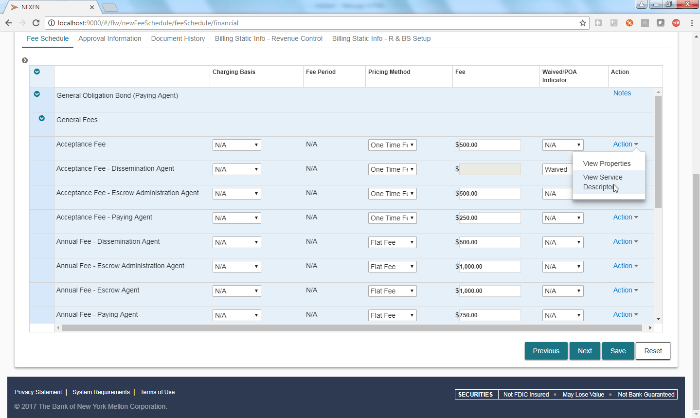

Service Descriptors can be reviewed and selected from the L3 screen using the icon labeled “Service Desc.” Clicking on “View Service Descriptor” in the Action drop-down list will bring up the following pop-up dialog box which will show the fixed text from the Product Catalog and a text input box for the free text.

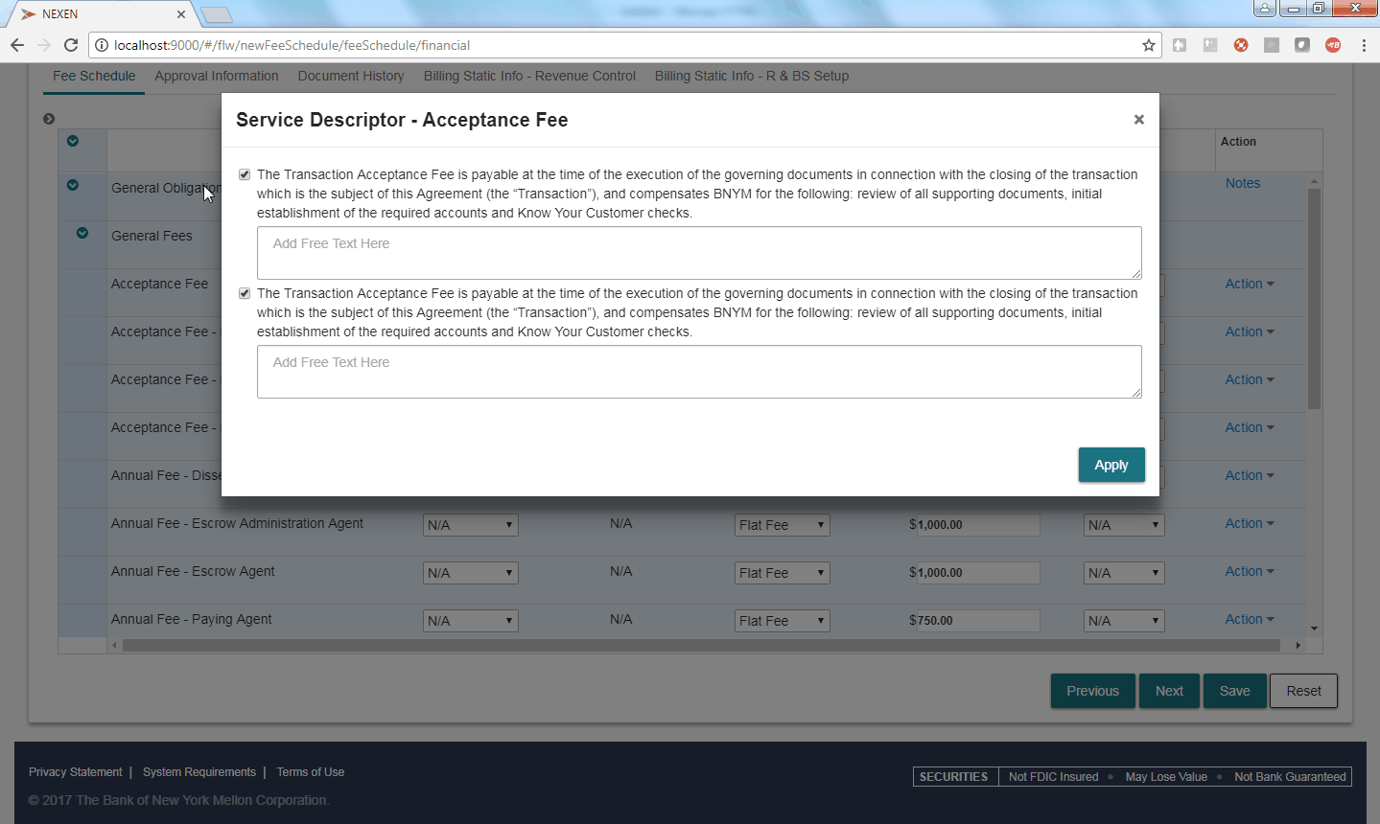

**Service Descriptor Details:**

* A new category of a new category of note type at the service level that when selected would appear below the service line on the pdf.
* In the User Interface, Service Descriptor Text will be supported from a drop-down selection from the [Action] button at the right margin of the screen. Clicking on “View Service Descriptor”will bring up the service descriptor text and selection functions.
* Users will be able to review service descriptor text and select/deselect text. Based on existing note logic for Standard & Mandatory/Optional Flags.
* Like footnotes Service Descriptor would be setup from the product catalog. Service Descriptors will need to be setup in advance. They would be referenced by a number at the service level. The number would have a prefix that would identify it as a service note : “SD”
* Users can have more than one Service Descriptor per service. Like footnotes each Service Descriptor would have its own paragraph.
* In the case of multiple services within a Service Group, each service could have single or multiple service notes (just like other note types).
* The Service Descriptor would **NOT** have superscript numbers, reference numbers or sequence numbers.
* (Like other note types ) Service notes Can be set to Standard/ Mandatory/ Optional
* Users would be able to select and De-Select Service Descriptors (unless they are designated mandatory).
* The Service Descriptor Text and note elements would be referenced from the existing notes tab in the product catalog
* Service Descriptor text upload from the product catalog would be supported by FeeFlow cloning functionality.
* Service Descriptor would follow the same formatting rules as existing footnote functionality (but without the footnote numbering detailed above). Special formatting (i.e. bullets, indented paragraphs, etc.) will be supported from the product catalog. Bullets can be entered directly from the product Catalog. Here is a sample:

This annual fee is payable at closing and on each anniversary thereafter. It compensates BNYM for the following:

• Notifying the Clearing Agent of the details of the proposed issue on due date or when required

• Logging the details of the proposed issue in the Clearing system as soon as practicable thereafter

• Initial set up of issuance

• Payment of Interest and Principal

• Responding to Noteholder inquires

* Note: Bold Text must be entered using HTML tags as follows: <b>[text]</b>. Additional special symbols need to be entered in HTML format from the product catalog (similar to current footnote functionality) .
* **Free Text:** The service descriptor pop-up will allow users to enter free text that will be specific to that schedule
* **Free Text:** The user added Free Text will be informational only. It cannot be used to drive any FeeFlow functions or processes, nor can it be used as data for interfaces into 3rd party systems
* **Free Text:** The Free Text box will support up to 4,000 characters (same as the other note types)
* **Free Text:** The user added text will default to the same left and right margins as the Service Descriptor fixed text
* **Free Text:** Free text fields will always be linked to a service descriptor
* **Free Text:** If a service descriptor is setup in the notes catalog it will always have a free text field
* **Free Text:** Users will have to select at least one service descriptor to enter free text.
* **Free Text:** Users will be able to enter multiple paragraphs within the free text entry box.
* **Free Text:** The free text entry box will need to be selected to enter text on to the schedule
* **Free Text:** User entered text will be supported in FeeFlow cloning functionality. Cloned schedules will include User Entered Free text from the original fee schedule; users will be able to select/de-select and edit the Free text in the cloned statement.
* **Free Text:** would follow the same formatting rules as items from the SD text from the product catalog. Special formatting (i.e. bullets, indented paragraphs, etc.) would be supported
* **Free Text:** : Bold Text must be entered using HTML tags as follows: <b>[text]</b>. Special symbols like ©, ™, ® need to be entered in appropriate HTML format.

# Corporate Trust Fee Schedule PDF Output

## Fee Schedule Samples (Distribution and Annotated)

Fee Schedules are generated by clicking on the “Generate PDF” link the user can review a draft copy of the fee schedule.

Fee Schedule Distribution Version



Fee Schedule Annotated Version



## Fee Schedule CT PDF Format Enhancements

### Corporate Trust Specific Formatting: Fee Schedule PDF template

Selecting “Corporate Trust” in the Line of Business field on the deal summary page will bring up a separate corporate trust PDF template that incorporates current Corporate Trust Fee Schedule formats (see attached sample). This format will be quite different from the current Asset servicing fee templates

1. Cover page will conform to the current Corporate Trust fee schedule standard :
2. The schedule will include Corporate Trust specific headers and footers
3. “Service – Role” Display Order: When the Service name is followed by Role Name “N/A” This will always be displayed first. After that, the Service Name and Role combination will be sorted by role name in alphabetical order when service name is same.
4. The asset service version of the Table of Contents needs to be removed (including the page break) or display suppressed. The schedule should go directly (with a page break) from the cover page to the Fee Schedule Introductory text
5. Product Descriptions should not be displayed. While product descriptions will be available in the UI and part of the Fee Schedule setup. The PDF output should suppress the display of the Product description
6. Unlike current Asset Servicing Schedules, Corporate Trust PDF Fee Schedules should not automatically page break at the product level. Page Breaks should happen when the end of the page is reached
7. When there is a page break in the middle of a table grid, the table will continue on the next page and the column headers will be repeated on the following page **– Currently Supported**
8. Foot-notes, Additional notes and Service Descriptors will not be split on a page break. For example if you have a footnote 1 and footnote 2, and footnote 2 page breaks in the middle, all of footnote 2 will be carried to the new page. **– Currently supported**
9. Footnotes will have numbers. Additional Notes and Service Descriptors will not have numbers.
10. Value based fee amounts and percentages will not show decimal places on the PDF schedule. Current decimal support will be maintained in the FeeFlow UI, but PDF will show whole numbers only. Will use Half round up rounding logic that rounds up for values >=.5 and rounds down for values < .5.

### Corporate Trust Format Cover Page

Used when Line of Business = “Corporate Trust”

Corporate Trust Cover Page

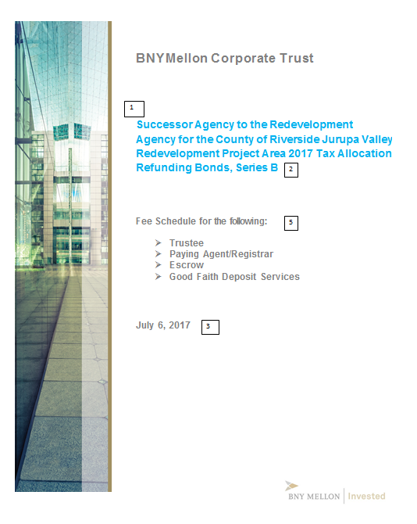

1. The Corporate Trust Cover page entries will be dependent on manual updates to the Maintain Cover Page. Cover Page entries (and footnote entries below) will need to reference those field values.

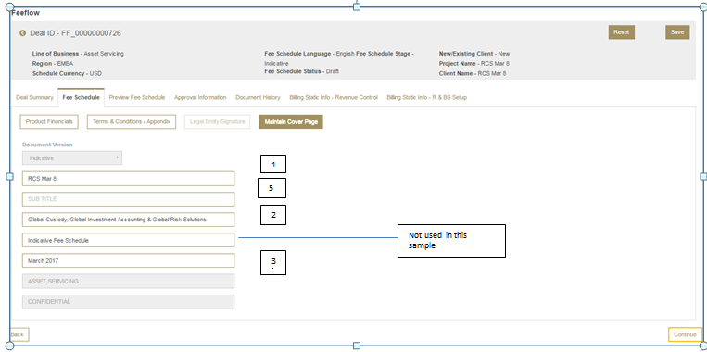

2

3

Not used in this sample

5

1

1. CT cover page: Field Mapping:

| **Ref. #** | **Business Name** | **FeeFlow Maintain Cover Page Fields** | **Field Length (chars)** | **Comments** |
| --- | --- | --- | --- | --- |
| 1 | Client Name | [Title Header] | 240 |  |
| 2 | Product | [Body] | 240 | No space with Client Name |
| 3 | Date | [Time Stamp] | Standard Full Date Format | Note: Manually added MM/DD/YYYY or DD/MM/YYYY format (do not validate format) |
| 4 | Presented By | Hardcoded “BNY Mellon Corporate Trust” | 240 |  |
| 5 | Role | [Sub Title] | 240 | “Fee Schedule for the following” <CR> + Role Names <CR> (Bullets and other format characters can be put in front of role names) |
| N/A |  | [Body2] | 240 |  |

Note: If entered text exceeds 240 characters, we will not fail the display, but we would display the characters up to the limit.

### Relationship Manager Details and Deal Parameter Information

Certain business units add the following information to the cover pages of their statements:

* 1. Relationship Manager Details

**Presented By:**

**RM Name**

**Senior Relationship Manager**

**BNY Mellon Corporate Trust**

**(212) 815-0000**

**rm.name@bnymellon.com**

* 1. **Transaction Parameters**

**Transaction Parameters:**

* Currencies Required: USD, GBP, EUR
* This account will receive up to 15 bank loans with an aggregate balance of loans to be approximately $500MM
* These loans wil be set up and maintained on our WSO Bank Loan Administration system

**Note:** For Release 1A this information will not be supported on the Statement cover page. It will be available in the body of the Fee Schedule via FeeFlow’s “Appendix” (currently Appendix A for Asset Servicing) function; which allows users to enter free format text directly into the Schedule.

### Fee Schedule Introductory Text

*Subject to the Terms and Disclosures below, upon appointment of* **[BNYM Legal Entity]** *(“BNYM” or “us” or “affiliates” or “subsidiaries”) in the roles as outlined within this Fee Schedule (this “Fee Schedule”),* **[Title Header]** *(“****you****”) shall be responsible for the payment of the fees, expenses and charges as set forth herein. Fees are payable or accrue at the time of the execution of the governing documents (the “Transaction Documents”) in connection with the closing of the transaction (the “Transaction”) which is the subject of this Fee Schedule.*

Note:

1. BNYM Legal Entity Text provided from Deal Summary Screen input.
2. Title Header text will be provided from the maintain cover page field.

### Corporate Trust Headers

1. PDF schedules will have headers based on manually entered field data from the Maintain Cover Page data fields.
   1. Headers will be available on all pages except the Cover Page. (See attached schedule sample )
   2. Header Sample (Data Source: FeeFlow Maintain Cover Page Fields):

|  |  |  |
| --- | --- | --- |
| **BNY Mellon Corporate Trust** | | |
| **Fee Schedule for [Client Name], [Product]** | | |
| **Ref #** | **Business Name** | **FeeFlow Maintain Cover Page Fields** | |
| 1 | Client Name | [Title Header] | |
| 2 | Product | [Body] (only display first product; delimited by [C/R] character) | |

### Corporate Trust Footer Format

1. PDF Footers will be displayed on all pages except the Cover Page
2. PDF schedule footers will be a combination of fixed format data and [Fee schedule ID]

**Footer Sample:**

PRIVATE AND CONFIDENTIAL

The information contained within this Fee Schedule is the proprietary information of The Bank of New York Mellon and is confidential. Except as otherwise provided by law, this document, either in whole or in part, must not be reproduced or disclosed to others or used for purposes other than that for which it has been supplied without the prior written permission of The Bank of New York Mellon.

|  |  |  |
| --- | --- | --- |
| Corporate Trust | Bank of NY Mellon: **[Fee Schedule ID]** | Page # |

**End Sample**

### Service Descriptor (See Section 6.3 for functional details and business rules)

Corporate Trust Users have requested that additional text be added to current FeeFlow functionality to provide enhanced text description for services. Unlike footnotes these service descriptors would provide an additional category of text detail that would always go underneath the Role/Fee services group as explanatory text. Also service descriptors will not have numbers (See example)

Service Descriptor Example 1

|  |  |
| --- | --- |
| **Annual Fees [Service Group]** | |
| **Annual Fee – Paying Agent Fee** [Service] – [Role], [Charging Basis = “N/A”], [Fee Period] = “N/A” | **$325** |

An annual charge covering normal paying agent duties related to account administration and bondholder services. Our pricing is based on the assumption that the bonds are DTC-eligible/book-entry only. If the bonds are certificated or physical, an additional fee per year will be added to the Annual Paying Agent Administrative fee. This fee is payable annually, in advance. [Service Descriptor text]

|  |  |
| --- | --- |
| **Transaction Fee – Paying Agent, Per Transaction** [Service] – [Role], [charging basis] , [Fee Period] = “N/A” | **$ 25** |

An annual charge covering normal paying agent transactions related to account administration and bondholder services. [Service Descriptor text]

### Signature Support

Corporate Trust will use the same approach to managing signatures as the current Asset Servicing version of FeeFlow.

1. The screen will default to one signature pair entity

***Agreed and accepted for effective date__________________________________________ by:***



1. Additional signature pairs can be added from the User Interface.
2. The user can select a BNY legal entity from the drop down list
   1. Note: For those users who do not want to use a formal legal entity FeeFlow will also provide the general description “Bank of New York Mellon” in the drop-down list

# FeeFlow System Screens

## FeeFlow Landing Page (Sign-in page)

After sign-on this is the initial page of the system. The page provides a summary list of all current fee schedules and the latest status of those schedules (Figure 1)

### Screen Sample

Figure 1 Fee Schedule Summary

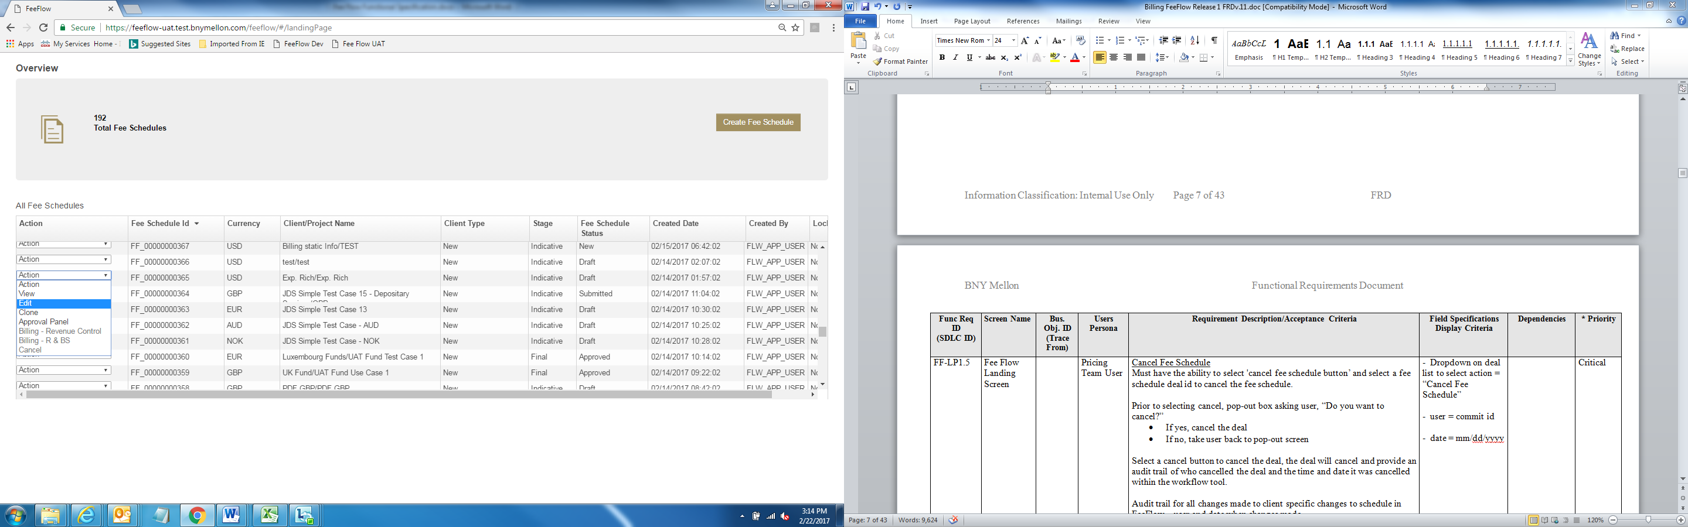

3

1

2

### Fee Flow Landing Screen Details

| BRD Section Reference | ID # | Release | Object Name | Object Type | Requirement Description/Acceptance Criteria | Field Specifications  Display Criteria | Comments |
| --- | --- | --- | --- | --- | --- | --- | --- |
|  |  |  | Overview | Screen Title | UI description of Screen |  |  |
| 3.7 | 1 |  | Total Fee Schedule | Message Field | Shows number of open fee schedules | # of Open Schedules + “Total Fee Schedules” |  |
| 1.3.1 | 2 |  | Create Fee Schedule | Button | Button that allows the user to jump to Deal Summary – Deal Information Screen to create a new fee schedule | Button = “Create Fee Schedule” |  |
| 3.7 | 3 |  | Action | Field Name | Drop down list that provides users with action choices for open fee schedules | * Action List * View * Edit * Approval Panel * Billing – Revenue Control * Billing – R&BS * Clone Fee Schedule * Cancel | Depending on the user entitlement and the status of the fee schedule, certain choices may be greyed out and not operable. |
| 3.7 |  | 1A Screen | Fee Schedule ID | Field Name | Displays Fee Schedule ID’s for open Fee Schedule | ID numbers can be sorted in ascending or descending order |  |
| 3.7 |  | 1A | Currency | Field Name | Shows the currency of the open Fee Schedule |  |  |
| 3.7 |  | 1A | Client/Project Name | Field Name | Shows the combination of the Client and Project Name | Concatenation [Client ] +/+[Project Names] |  |
| 3.7 |  | 1A | Client Type | Field Name | Identifies if the client type | Applicable Values   * New * Existing * Existing – New to FF |  |
| 3.7 |  | 1A | Stage | Field Name | Identifies the stage of the process of fee flow creation | Applicable Values   * Indicative * Final | * Indicative: Fee schedule is still being reviewed and amended as part of the negotiation process * Final: Fee Details have been reviewed, approved and schedule is ready for submission to client * See Section **8.1** for details on schedule creation and approval process |
| 3.7 |  | 1A | Fee Schedule Status | Field name | Shows the status of Fee Schedule | Draft  Approved  Submitted | See Section **8.1** for details on schedule creation and approval process |
| 3.7 |  | 1A | Created Date | Field Name | Shows the date and time of when the fee schedule was created | Date Format: display dependent on user’s region | Region Date format  EMEA: DD/MM/YYYY  AMERICA/ASIA:MM/DD/YYYY |
| 3.7 |  | 1A | Created BY | Field Name | User ID of Person who created the Fee Schedule |  |  |
|  |  | 1A | Locked | Field Name | Identifies if the fee schedule is locked because it has been opened by another user. |  | If Locked = “Y “ Schedule is opened by another user and cannot be accessed. |

## Figure 2 Deal Summary Screen (Create Fee Schedule)



6

### Deal Summary – Deal Information

| Figure 2 ID # | Release # | Object Name | Object Type | Data Source | Requirement Description/ Acceptance Criteria | Field Specifications  Display Criteria | Comments |
| --- | --- | --- | --- | --- | --- | --- | --- |
| 1 | 1A | “New Fee Schedule “ | Message Field |  | UI description of Screen | Upper left had of screen (see Figure 2) |  |
| 2 | 1A | “<” | Action icon |  | Clicking the icon Returns User to Summary Landing Screen | :”<” + “ New Fee Schedule” |  |
| 3 | 1A | Created On | Message Field + Date |  | System adds Current Date as created date for the fee schedule | “Created On” + Current Date |  |
| 4 | 1A | Current Status | Message Field |  | Shows the current status of Fee schedule: | “Current Status” + Current Status | During the Create Fee Schedule Process the Status will be “New”.  Value will dynamically change when fee schedule status changes |
| 5 | 1A | Reset | Action Button |  | Resets screen: | “Reset” |  |
| 6 | 1A | Save | Action Button |  | Saves Current Screen Input | “Save” | All input fields fields on Deal summary tab need to be filled in or error message : |
| 7 | 1A | * Deal Summary * Fee Schedule * Preview Fee Schedule * Approval Information * Document History * Billing Static Info – Revenue Control * Billing Static Info – R&BS Setup | Screen Tab |  | Allows user to navigate to specific screens in the Schedule Creation process | See Figure 2 | Based on Fee schedule creation status: Only screens that are applicable will be available. Tabs for screens not available will be greyed out. |
| 8 | 1a | Line of Business | Input Field |  | Drop down list of designated Lines of Business for the user’s role and entitlement | Add “Corporate Trust” to drop down list | Required Field |
| 9 | 1a | Region | Input Field |  | Drop down list of designated Regions for the user’s role and entitlements | Fixed List; selection from drop down list | Required Field |
| 10 | 1a | Schedule Currency | Input Field |  | Drop down list of designated currencies for the user’s role and entitlements | Fixed List; selection from drop down list | Required Field |
| 11 | 1a | Fee Schedule Language | Input Field |  | Drop down list of designated Languages for the user’s role and entitlements | Fixed List; selection from drop down list | Required Field :  Current Languages :   * English |
| 12 | 1a | New/Existing Client | Input Field |  | Drop down list | Fixed List; selection from drop down list:  1 New  2 Existing  3 Existing – New to FF | New: Client is new to both billing and fee flow  Existing: Client has had existing fee schedules in Fee flow  Existing-New to FF: Legacy clients with existing schedules but new to FeeFlow |
| 13 | 1A | Client Name | Input Field |  | User Inputs Client Name |  | For Vesion 1A, required field |
| 14 | 1A | Client Type | Input Field |  | Drop Down List of Client types | Asset Serv. Client Type  Fund  Financial Institution  Pension – Netherlands  Pension – Ireland  Pension – UK  Pension - Other | Need Corporate Trust list. This should be separate from Asset Servicing |
| 15 | 1A | Project Name | Input Field |  | User Inputs Project Name |  |  |
| 16 | 1A | Fee Schedule Stage | Display Field |  | Show Fee Schedule Stage | For schedule creation defaults to “Indicative” when schedule is first saved | For Fee Creation: Defaults to Indicative. Greyed out so users can’t change. Note: Field will say ‘Indicative’ even when Current Status says ‘New’ |
| 17 | 1A | BNYM Legal Entity | Display Field |  | Drop down list of available legal entities | Note this should only be available when Line of Business = “Corporate Trust” | Use current legal entity selection functionality for signatures. |

## Fee Schedule – Product Selection

Clicking Continue on the Deal Summary Screen will navigate the user to the Product Selection Screen. This screen shows the available products based on catalogs provided for the Region and Line of Business.

Users will check the products they want to include in the fee schedule.

### Product/Service Selection Screen (L2)

User can drill down into the specific services for the selected products. The product catalog will identify which services will be pre-selected and which services will be mandatory and which will be optional.



### Fee Schedule Setup Detail (L3) - Expanded

Continuing from the Fee Schedule Setup Screen (L2) the L3 screen provides the detailed fee templates to add the pricing methods and the specific fees. Note: Default values on this screen are taken from the Fee catalog for those products and services. Pricing methods can be changed and standard rates can be overridden.

For Corporate Trust both the product/service/role will be displayed



Additional details on pricing are available in the “Action” link at the end of each line. For example: Step Tier Pricing details:

Note: Full details on Step Tier Pricing: (See Section 10.1 )

Step Tier Detail for Unit based pricing

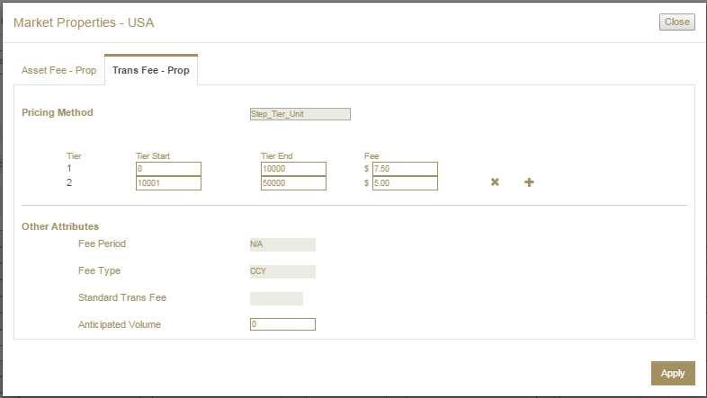

### Review Fee Schedule: Maintain Cover Page

Users can change the text that will be displayed on the Fee Schedule cover page. Mandatory fields are greyed out

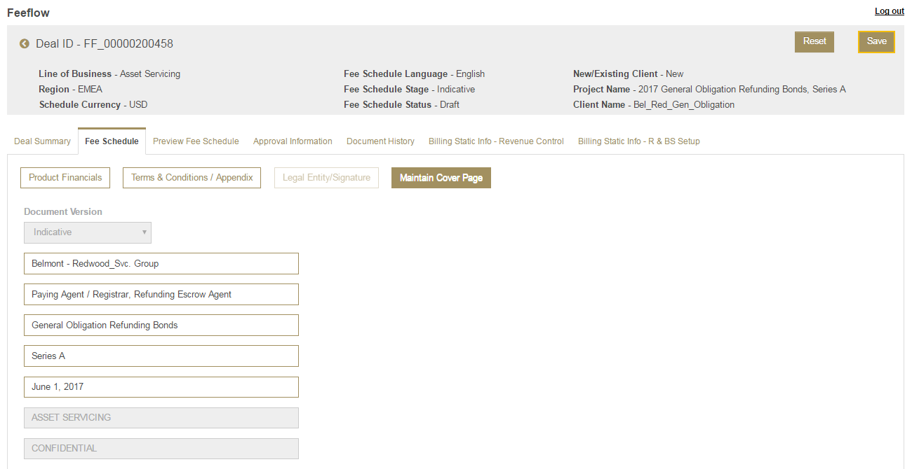

### Preview Fee Schedule

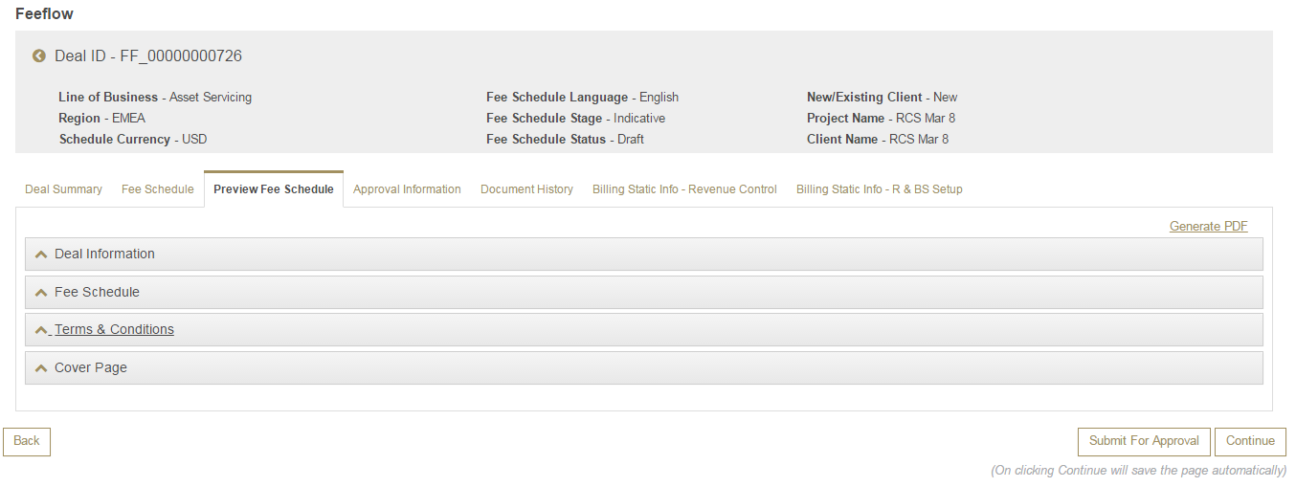

# Fee Schedule Approval

The User then submits the Fee Schedule for Approval. With submission the Fee Schedule is locked and cannot be changed

For future releases role based Entitlement functionality will be added and users can be restricted to certain process and functions.

Currently the System tracks approval status and allows all users to approve or reject submitted schedules

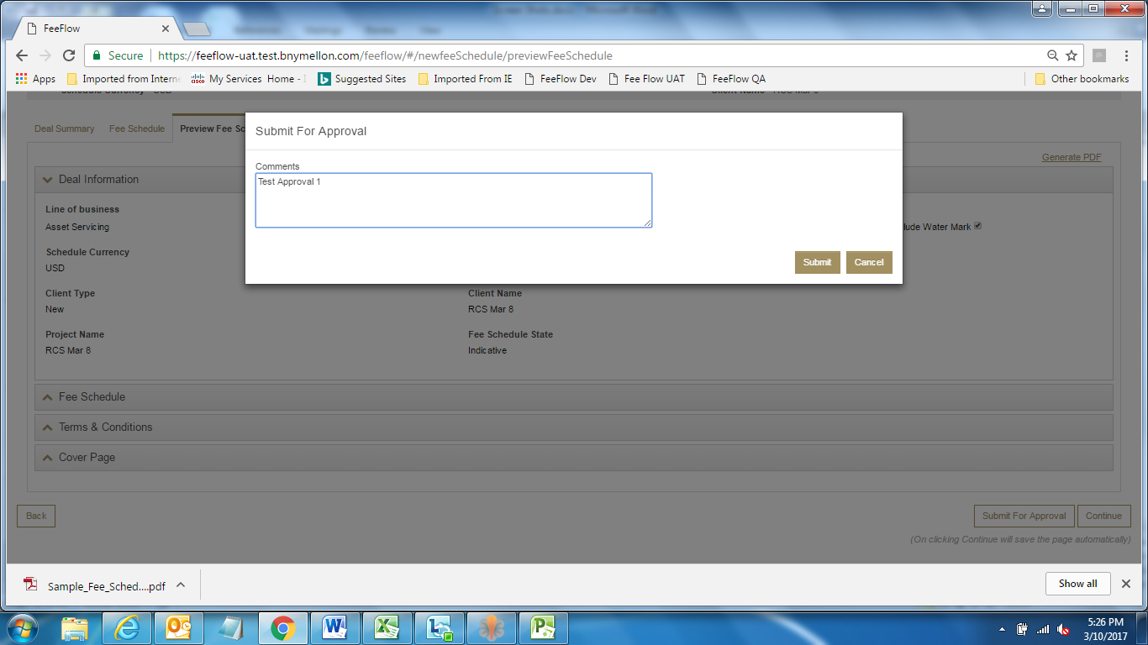

# Tier Pricing Details for CT

## Tier Types

Users will be able to setup tiered pricing arrangements on the L3 Screen Pricing Method/Charging Basis Asset Fee or Transaction Fee. Options are:

### Step Tiers

The FeeFlow Step Tier calculates each tier at a per item or value level charge and calculate the first 20 at $5.00, the next 20 - 40 at $2.00 and any item after 40 at an additional $1.00.

|  |  |  |
| --- | --- | --- |
| Tier Start | Tier End | Fee |
| 0 | 20 | $5.00 |
| 21 | 40 | $2.00 |
| 41 |  | $1.00 |

### Per item Flat Tiers:

A Per item Flat Tier calculates each tier at a per item charge, but only bills the per item charge at the rate where the last tier falls. An example:

|  |  |  |
| --- | --- | --- |
| Tier Start | Tier End | Fee |
| 0 | 20 | $5.00 |
| 21 | 40 | $2.00 |
| 41 |  | $1.00 |

For a count of 50, a banded per item tier will calculate all 50 items at $1.00 per item.

### Banded Flat Tier – New for Corporate Trust

A Banded Flat Tier counts the units but rather than charging per item, just the amount of the band is charged.  Below is an example

|  |  |  |
| --- | --- | --- |
| Tier Start | Tier End | Fee |
| 0 | 20 | $50.00 |
| 21 | 40 | $25.00 |
| 41 |  | $10.00 |

At a counter of 50, a banded flat will calculate all 50 items at a flat rate of $10.00.

## Tier Fee Rules

1. Up to 9 tiers will be available
2. Fee Flow will check to confirm tiers are setup correctly
3. Ranges should be in ascending order
4. No gaps between tiers
5. A set of tiers will always begin at one or zero
6. A set of tiers should always end higher; No High to low should be permitted
7. For volume tiers the next tier should always start from the end of the previous tier.
   1. For value tiers must match end previous = start current
   2. If counts (unit) tier the next tier should always start from the end of the previous tier plus one.
   3. Unit tiers start = end of prev Tier +1 (unit tiers do not have decimals)
8. The last Tier End can be closed (can have a value) or open-ended (field is blank).
9. For period based tiering: Fee Flow provides the following support:

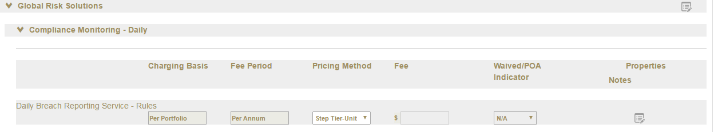

1. Period is set during service selection, step tier is selected in the service details
2. Tier details are available in Properties pop-up

Step Tier Detail for Unit based pricing

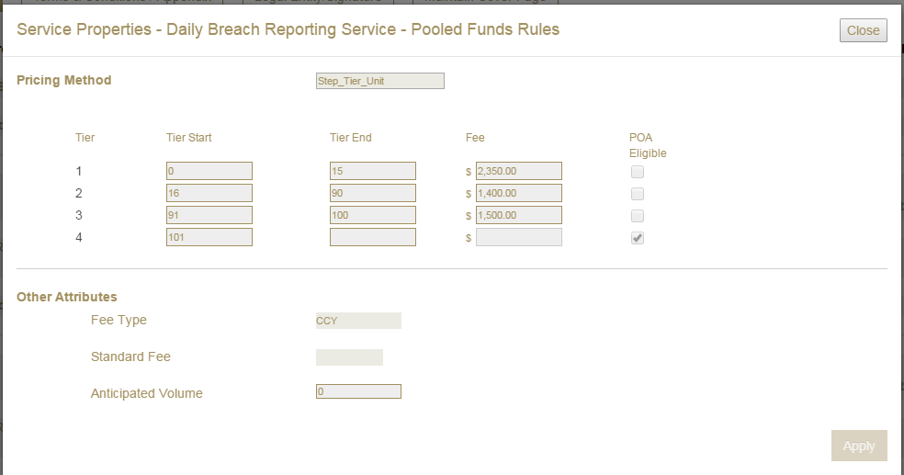

Example One: Volume Tiering - Ranges - Open

|  |  |  |
| --- | --- | --- |
| Tier Start | Tier End | Fee |
| 0 | 2,500 | $10.00 |
| 2,501 | 5,000 | $7.50 |
| 5,001 |  | $5.00 |

Example Two: Volume Tiering - Ranges - Closed

|  |  |  |
| --- | --- | --- |
| Tier Start | Tier End | Fee |
| 0 | 2,500 | $10.00 |
| 2,501 | 5,000 | $7.50 |

Note if volume > 5,000, item would be charged at $7.50

Example Three: Value Tiering – Currency - Open

|  |  |  |
| --- | --- | --- |
| Tier Start | Tier End | Fee |
| 0 | USD 100 million | 3.00 bps |
| USD 100 million |  | 1.00 bps |

Example Four: Value Tiering – Currency - Closed

|  |  |
| --- | --- |
| 0 – USD 100 million | 5.00 bps |
| USD 100 million – USD 250 million | 2.50 bps |
| USD 250 million – USD 500 million | 1.25 bps |

## Step Tier Fee: Input Scaling

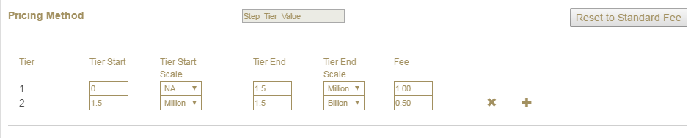

1. Pop-up Properties provides a drop down box that allows users to designate the display scale of the Tier Start and Tier End amounts on the PDF. The following choices will be available:
   * 1. Billion (value/units in 000,000,000)
        1. Users must enter the scaled amount i.e. 2.5 for 2.5 billion
2. Users cannot enter more than 2 decimal places
   * 1. Million (value/units in 000,000)
        1. Users must enter the scaled amount i.e. 2.5 for 2.5 million
        2. Users cannot enter more than 2 decimal places
     2. NA (value/units: amounts not scaled)
        1. Users must enter the full amount
        2. Users cannot enter any (0) decimal places
3. Users can set the scale for the starting and ending amounts within each tier
   * 1. For a single tier the End Scale cannot be less than the start scale
        1. You cannot have Billion scale in Start but Million scale in End
     2. For multiple Tiers: the Start Scale of the next tier must equal End scale of the previous tier.
        1. If the End Scale of Tier 1 = Millions then the Start Scale of Tier 2 must = Millions
           1. System should default this

can’t support defaults for 1A1

Will support validation for 1A1

1. Scale settings apply only to the Tier Amounts. Actual Fee amounts will always be entered in units
   * 1. Fee amounts can be entered up to 6 decimal places.

# Corporate Trust Key Requirements

## Workflow and Approval Process

### The pricing user should have an ability to review the created Fee schedule and approval/reject or accept/decline the PDF Fee schedule (alone with the provision to download/print)

### Corporate Trust Business Requirements Reference 3.5, 3.6, 3.7

1. Within each Version of the use case, FeeFlow should allow users to re-open and edit the Fee Schedules multiple times over the Fee Schedule creation process.
   1. During the approval steps of the Fee Schedule creation, schedules will be locked and could not be unlocked or changed
2. FeeFlow will track the various updates, rejections and approvals for each of the Versions in the process. Status information will available in the Approved Information and Documentary History sections.

| Step # | Fee Schedule | Version ID | Stage | Workflow Status | Schedule PDF Version ID | Locked | EDG | Comments |
| --- | --- | --- | --- | --- | --- | --- | --- | --- |
| 1 |  | 1 | Indicative | Draft |  | N |  | Initial schedule created |
| 2 |  |  | Indicative | Submitted | PDF-1.1 | Y | Applicable | Schedule pending approval. System generates version # 1.1 |
| 3 |  |  | Indicative | Approved/ Rejected | PDF-1.1 | Y |  | Designated User approves or rejects schedule |
| 4 | If it is Rejected |  |  |  |  |  |  |  |
| 5 |  |  | Indicative | Draft |  | N |  | Rejection returns the schedule to Draft Status for changes |
| 6 |  |  | Indicative | Submitted | PDF 1.2 | Y | Applicable | Re-Submitted Schedule pending approval. System updates version # to 1.2 |
| 7 |  |  | Indicative | Approved/ Rejected | if rejected, goes back to Step 5 | Y |  |  |
| 8 |  |  | Indicative | Approved |  | Y |  | Go to Step 9 |
| 9 | If it is Approved from Indicative step (Step 8) | 2 | IND-Client Approval | Draft |  | N |  | Approval promotes Schedule from Indicative to IND-Client Approval Stage. Schedule is not locked and can be amended. |
| 10 |  |  | IND-Client Approval | Submitted | PDF-2.1 | Y | Applicable | Schedule pending approval. System generates version # 2.1 |
| 11 |  |  | IND-Client Approval | Approved/ Rejected |  | Y |  | Client or Designated User approves or rejects schedule |
| 12 |  |  | IND-Client Approval | Approved | if approved, goes to step 14 | Y |  |  |
| 13 |  |  | IND-Client Approval | Rejected | if rejected, goes back to step 5 | N |  |  |
| 14 | If it is Approved from IND -Client step 11 | 3 | Final | Draft |  | N |  | Promoted to Final Stage  Additional updates from BNY side available after indicative client approval |
| 15 |  |  | Final | Submitted | PDF-3 .1 | Y | Applicable | Schedule pending approval. System generates version # 3.1 |
| 16 |  |  | Final | Approved/ Rejected |  | Y |  | Designated User approves or rejects schedule |
| 17 |  |  | Final | Approved | if approved, go to step 19 | Y |  |  |
| 18 |  |  | Final | Rejected | if Rejected, go back to step 14 | Y |  | Notes say we can return to Indicatve status as well. Confirm this |
| 19 | If it is Approved from Final: Step 18 | 4 | FIN-Client Approval | Draft |  |  |  |  |
| 20 |  |  | FIN-Client Approval | Submitted | PDF-4.1 | Y | Applicable | Client reviews final Schedule |
| 21 |  |  | FIN-Client Approval | Approved/ Rejected |  | Y |  | Client decides to accept/reject |
| 22 |  |  | FIN-Client Approval | Approved |  | Y |  | if appproved, go to RBS & Revenue screens : Go to Step 24 |
| 23 |  |  | FIN-Client Approval | Rejected |  | N |  | If Rejected go to step 20 |
| **Workflow from #24 to #26 not in Scope for Release A and will be covered in the documentation for Release B** | | | | | | | | |
| 24 | RBS & Revenue screens |  |  |  |  |  |  |  |
| 25 |  | Revenue screen |  |  |  |  |  |  |
| 26 |  | RBS screen | Submit data for ADV |  |  |  |  | File sent to Corporate Trust Billing System |

### Key Points

1. Indicative to Final is not a one-way process. Users can move back from Final to indicative as many times as required by the approval process
2. Fee Schedules are no longer permanently locked down when Fee Schedule in Final State. Schedules can be re-opened and re-edited multiple times. (Note Fee Schedules are locked down during the final step when the schedule is sent to the Billing system for Release 1B)
3. Billing State included in process: In the “Billing” state Fee Schedules would be locked
4. Entitlement roles will be added and users can be restricted to certain process and functions.

## Entitlement Support – On Hold for Release 1A

FeeFlow will use Rules to organize Actions, Resources, Regions and specific attributes to control the Attribute Process. The table below gives an illustration of how FeeFlow addresses Entitlements through roles and rules. The release of Entitlement Functionality will follow Release 1A. The release dates will be provided when finalized

| Process | Role 1 | Role 2 | Role 3 | Role 4 | Role 5 | Role 6 | Role 7 |
| --- | --- | --- | --- | --- | --- | --- | --- |
|  | **Relationship Management & Development User1** | **Pricing User2** | **Pricing Manager2** | **Pricing System Adminstrator3** | **Revenue Control User2** | **R&BS User3** | **R&BS Product Management3** |
|  |  |  |  |  |  |  |  |
| Client Fee Schedules |  |  |  |  |  |  |  |
| Draft indicative fee schedules | X | X | X | X |  |  |  |
| Clone fee schedules (partial cloning) | X | X | X | X |  |  |  |
| Clone fee schedules (full cloning) |  | X | X | X |  |  |  |
| Submit indicative fee schedules | X | X | X | X |  |  |  |
| Review indicative fee schedules |  | X | X | X |  |  |  |
| Approve / Reject indicative fee schedules |  | X4 | X | X |  |  |  |
| Approve / Reject indicative fee schedules containing a watermark |  | X4 | X | X |  |  |  |
| View approved indicative fee schedules | X | X | X | X |  |  |  |
| Save draft final fee schedules | X | X | X | X |  |  |  |
| Submit final fee schedules | X | X | X | X |  |  |  |
| Review final fee schedules |  | X | X | X |  |  |  |
| View approved final fee schedules | X | X | X | X | X | X | X |
| Draft / edit fee schedules in Client Approval status |  | X | X | X |  |  |  |
| Submit fee schedules in Client Approval status |  | X | X | X |  |  |  |
| Approve / reject fee schedules in Client Approval status |  | X | X | X |  |  |  |
| View client approved final fee schedules | X | X | X | X | X | X | X |

### Entitlements for the FiRRe interface Process – Will be covered in Separate 1B functional documents

| Process | Role 1 | Role 2 | Role 3 | Role 4 | Role 5 | Role 6 | Role 7 |
| --- | --- | --- | --- | --- | --- | --- | --- |
|  | **Relationship Management & Development User1** | **Pricing User2** | **Pricing Manager2** | **Pricing System Adminstrator3** | **Revenue Control User2** | **R&BS User3** | **R&BS Product Management3** |
| Access / update to R&BS tab / page |  |  |  |  |  | X |  |
| Submit data to FiRRe |  |  |  |  |  | X |  |
| Review rejects from FiRRe |  |  |  |  |  | X |  |
| Resolve rejects from FiRRe |  |  |  |  |  | X |  |
| Access / update to Revenue Control tab / page |  |  |  |  | X | X |  |
| Upload signed final fee schedules | X |  |  |  | X |  |  |
| Enrich details for the signed final fee schedule |  |  |  |  | X |  |  |
| Submit to Revenue Control | X |  |  |  |  |  |  |
| Submit to Pricing |  |  |  |  | X |  |  |
| Reject to Pricing |  |  |  |  | X |  |  |
| Reject to Relationship Management & Development |  | X | X | X | X |  |  |

### Static Data Maintenance

| Static Data Maintenance |  |  |  |  |  |  |  |
| --- | --- | --- | --- | --- | --- | --- | --- |
| Update / edit / add fee schedule templates |  |  |  | X |  |  |  |
| Update / edit / add Markets / Depots |  |  |  | X |  |  |  |
| Update / edit / add Products |  |  |  | X |  |  |  |
| Update / edit / add Service Groups |  |  |  | X |  |  |  |
| Update / edit / add Services |  |  |  | X |  |  |  |
| Update / edit / add Footnotes |  |  |  | X |  |  |  |
| Update / edit / add Additional Notes |  |  |  | X |  |  |  |
| Update / edit / add Terms and Conditions |  |  |  | X |  |  |  |
| Static Data Maintenance |  |  |  |  |  |  |  |
| Update / edit / add Scope of Service |  |  |  | X |  |  |  |
| Update / edit / add product groups |  |  |  | X |  |  |  |
| Update / edit / add standard rates |  |  |  | X |  |  |  |
| Update / edit / add any other static data |  |  |  | X |  |  |  |
| Update Mapping |  |  |  |  |  | X |  |
| Approve new / updated Mapping |  |  |  |  |  |  | X |
|  |  |  |  |  |  |  |  |

| 1 Able to view only those clients / fee schedules in that region only, ideally restricted by Client Type(s) and BNY Mellon Legal Entity - see below |
| --- |
| 2 Able to view all fee schedules for all clients in that region - see below |
| 3 Able to view all fee schedules for all clients in all regions |
| 4 As long as the same user did not draft it |
|  |

### Entitlement support for Regions

See Appendix 10.6 for full list of Regions

Also “Global User”

1. The system should provide capability to setup custom rules for exception cases.
2. Data Segregation by Region
3. Users can be assigned single or multiple Regions
   1. Global Scope would cover all regions

### Other Entitlement Rules

1. Ability to hide client name
2. Rules should be assigned to Specific Users/ Groups

* Users can be assigned single or multiple roles
* User Attributes can be assigned to specific users to control entitlements. The following Attributes should be considered:
  + Products
  + Line of Business
  + Roles
* Attribute roles by Currencies
  + Currency by Regions

# Glossary of Terms

## Terms and Abbreviations

The table below provides a listing of terms and abbreviations used throughout this document.

|  |  |
| --- | --- |
| Term/ Abbreviation | Definition |
| CT | Corporate Trust abbreviation |
| FeeFlow | Work Flow tool to create Client Fee Schedules |
| FeeFlow Database | Tool used to house Client Fee Schedules, Standard Rates for services and activities, Template Accounts, Product Catalog, Footnotes, terms and conditions, additional notes |
| Data Load | Tool used to send Client Fee Schedule data into FiRRe |
| R&BS | Revenue and Billing Services |
| Product Catalog | Catalog of Products/Roles/Service Groups/Services used within FeeFlow to create Client Fee Schedules. The product catalog defines the fee choices available to the users based on Region, Business Unit, Product Selection, etc. Each Product will have it’s own catalog |
| Region | Corporate Trust Business Regions |
| Product | Product or service being sold |
| Role | Person who performs a specific function for the product(s) sold |
| Service Group | A collection of services |
| Service | Lowest level of pricing hierarchy, activity or value. where fee amounts are listed |
| Client Segment | An information field for additional Analysis |
| Legal Entity | Controls certain roles and services |
| Region | Corporate Trust Business Regions |
| Product | Product or service being sold |
| Role | Person who performs a specific function for the product(s) sold |
| Account Type | Client Type: Used in Fee Flow to organize services |

# Appendices

## Corporate Trust Product List

### For 1A implementation

| **Product** |
| --- |
| Corporate (SAB) with FMB Apr 2014 |
| High Yield Bonds-June 2014 |
| Fixed and Variable Rate Revenue Bonds-Feb 2015 |
| General Obligation Bonds |
| Activity Fees |

Sharepoint Link;

<https://myshare.bnymellon.net/sites/fmtsebu/corporatetrustfeescheduleworkflow/Shared%20Documents/Forms/AllItems.aspx?RootFolder=%2Fsites%2Ffmtsebu%2Fcorporatetrustfeescheduleworkflow%2FShared%20Documents%2FCorporate%20Trust%20Project%2F3%2E%20Definition%2FProduct%20Catalogs%2FFee%20Flow%20Prod%20Catalog%20Corp%20Trust%20Finalized&FolderCTID=0x0120003A12D99F1B858E47AC72E752C67CCC37&View=%7BC75A48AC%2DDBD4%2D440E%2D8E0F%2DFBCF34D1487C%7D>

### Post 1A Implementation

| **Product** |
| --- |
| ABS-Feb 2016 |
| FATCA Pricing Matrix - May 12, 2016 |
| AA - Core Services as at 200613 v1 |
| AA - EMEA Amendments Pricing Matrix 2013 |
| Activity Pricing Matrix - May 12, 2016 |
| Arbitrage Svcs-November 2013 |
| Carbon Credits-Nov 2012 |
| Cat Bond-May 2014 |
| Certificate of Deposit-May 2013a |
| CLO Fee Schedule - July 2013 |
| CMBS-CRE-Sept 24, 2012 |
| Collateral Monitoring-Dec 10, 2012a |
| Commercial Paper-Oct 22, 2012a |
| Corporate Admin Services (CAS)-Amended Feb 2016 |
| Covered Bond-(Global) April 2014 |
| Medium Term Note- Oct 2014v |
| Debenture-May 2013a |
| Defeasance Trust-Dec 10, 2012v |
| Direct Pay and Tax Credit Bonds-Oct 29, 2012 |
| Diversified Payment Rights-Dec 3, 2012b |
| Document Custody-Sept 17, 2012a |
| Equity Paying Agent-Sept 17, 2012 v1 |
| Escrow-July 23, 2012v |
| Insurance Trust - May 2014 |
| Custody Pricing - Sep 2015v1 |
| Islamic Finance-Sukuk-Nov 26, 2012 |
| Listing Services-Feb 2014 |
| Loan Admin (Buy-side) - Mar 2016 |
| Loan Participation Notes-(11-09-2014) - |
| Master Servicing-Dec 3, 2012 |
| Project Finance - Nov 2015 |
| Repack-July 11, 2013 |
| Resecuritizations - May 2014 |
| RMBS Pricing Matrix Global update 24Feb2014 |
| Royalty Trust-Oct 29, 2012 v1 |
| Secondary Insurance-May 2014 |
| Securities Intermediary-Oct 1, 2012 |
| Settlement Agent role Sep 2014 |
| Sovereign Debt- May 2013a |
| SPV Admin-Sept 24, 2012a update Oct 29 Legal Fees |
| Student Loan-Nov 26, 2012 |
| Tender and Exchange-Aug 20 2012 v1 |
| Tender Option Bond-Oct 29, 2012a |
| Third Party Admin Agent Pricing Matrix Nov 2015 |
| Warrant - June (2) 2013 v1 |
| Whole Loan Tri Party Repo-Dec 3, 2012 v1 |

## Product Catalogs List (Sharepoint Link)

### <https://myshare.bnymellon.net/sites/fmtsebu/corporatetrustfeescheduleworkflow/Shared%20Documents/Forms/AllItems.aspx?RootFolder=%2Fsites%2Ffmtsebu%2Fcorporatetrustfeescheduleworkflow%2FShared%20Documents%2FCorporate%20Trust%20Project%2F3%2E%20Definition%2FProduct%20Catalogs%2FFee%20Flow%20Prod%20Catalog%20Corp%20Trust&FolderCTID=0x0120003A12D99F1B858E47AC72E752C67CCC37&View=%7BC75A48AC%2DDBD4%2D440E%2D8E0F%2DFBCF34D1487C%7D>

## Charging Basis List

| CHARGING BASIS |
| --- |
| At cost |
| At Occurrence |
| At-Cost |
| Basis Points |
| Flat Fee |
| NA |
| of Outstanding Principal Balance |
| On Outstanding value of Portfolio |
| One Time |
| Per Account |
| per Annum |
| per Calculation |
| Per clearing system participant certificate & per coupon payment |
| per Conversion |
| Per Currency |
| per CUSIP |
| per CUSIP per Tranche |
| per CUSIP/ISIN |
| Per Definitive Bondholder/Investor |
| Per direct or indirect beneficiary |
| Per draw |
| Per event |
| per Exchange |
| Per filing |
| per Fund |
| per Hour |
| per Indenture |
| Per investment |
| per Issue |
| Per Issuing Entity |
| per Item |
| per Lender |
| Per Line Item |
| Per Loan |
| Per modification |
| Per Note Holders |
| Per Payment / Per Tranche |
| per Position |
| per Program |
| per Put Option |
| Per rate fix |
| Per Recalcitrant Account |
| Per report |
| per Series |
| per Settlement |
| Per submission of paying agent certificate to issuer & per ISIN & per coupon payment |
| Per subsequent series |
| Per supplement |
| per Tranche |
| Per Tranche / Per Annum |
| per Tranche per Closing |
| per Transaction |
| Per transfer |
| per W-8 |
| per wire transfer |

## Pricing Method List

| PRICING METHOD |
| --- |
| Fixed |
| Flat Tier - Value |
| Flat Tier - Unit |
| Flat Fee |
| Banded Flat Tier Value |
| Banded Flat Tier Unit |
| One Time |
| OOPES (out of pocket) |
| Pass Through |
| per Activity |
| per Transaction |
| Step Tier Value |
| Step Tier Unit |
| Unit |
| Value |
| Variable |

## Fee Period List

| FEE PERIOD |
| --- |
| Annual |
| Annual Rate |
| Annual/At closing |
| As Incurred |
| At Closing |
| at Closing/Issuance |
| At each amendment |
| At each closing |
| At signing / closing |
| At Termination |
| At Time of Service |
| Closing/Issuance Date |
| Daily Basis |
| Monthly |
| Monthly Basis |
| Monthly/Quarterly |
| N/A |
| On closing |
| Payable from FiRRe pre-paid (code ##) |
| per Annum |
| Per month |
| Per month/At closing |
| per Quarter |
| Per Week |
| Quarterly |
| Weekly Basis |

## Corporate Trust Region & Currency Lists

Note Descriptions are all upper case and hyphen “-“ does not have any spaces

| REGION(S) |
| --- |
| APAC |
| AUSTRALIA |
| CANADA |
| EMEA |
| LATAM |
| US |
| US–GOVT. |

| Lob_cd | Region Code | Currency Code | Currency Desc | Symbol |
| --- | --- | --- | --- | --- |
| CT | AMERICAS | USD | US DOLLAR | $ |
| CT | ASIA | USD | US DOLLAR | $ |
| CT | EMEA | EUR | EURO | € |
| CT | EMEA | GBP | POUND STERLING | £ |
| CT | EMEA | USD | US DOLLAR | $ |
| CT | AMERICAS | USD | US DOLLAR | $ |
| CT | AMERICAS | CAD | CANADIAN DOLLAR | CAD |
| CT | ASIA | HKD | HONG KONG DOLLAR | HKD |
| CT | ASIA | JPY | YEN | ¥ |
| CT | ASIA | SGD | SINGAPORE DOLLAR | SGD |
| CT | ASIA | USD | US DOLLAR | $ |
| CT | ASIA | AUD | AUSTRALIAN DOLLAR | AUD |
| CT | EMEA | HKD | HONG KONG DOLLAR | HKD |
| CT | EMEA | EUR | EURO | € |
| CT | EMEA | GBP | POUND STERLING | £ |
| CT | EMEA | JPY | YEN | ¥ |
| CT | EMEA | NOK | NORWEGIAN KRONE | NOK |
| CT | EMEA | SEK | SWEDISH KRONA | SEK |
| CT | EMEA | SGD | SINGAPORE DOLLAR | SGD |
| CT | EMEA | USD | US DOLLAR | $ |
| CT | EMEA | AUD | AUSTRALIAN DOLLAR | AUD |
| CT | EMEA | CAD | CANADIAN DOLLAR | CAD |
| CT | EMEA | CHF | SWISS FRANC | CHF |
| CT | EMEA | DKK | DANISH KRONE | DKK |

## Client Type List

|  |
| --- |
| **Client Types** |
| Corporates |
| Financial Institutions |
| Insurance |
| Public Finance |
| Sovereign |
| Govt Solutions |
| Govt Solutions - Hybrid |
| All |

Note: Selecting “N/A” on the deal summary screen is the equivalent of selecting “All”

## Terms and Conditions Catalog Sample

